CSE3020 - Product Definition and Validation

PROJECT REPORT ON

**BillBook - Billing Pattern made simple!**

Faculty: Dr. **Hussain Syed**

**Submitted By: Group 4**

**1.Talasila Sri Harsha- 19BCE7490 (Team Lead)**

**2.** **Abhipray Adhik Chavan-19BCN7062**

**3. Neha Chowdary-19BCE7097**

**INDEX**

1. INTRODUCTION

1.1 Introduction

1.2 Literature survey

1.3 Problem introduction

1.4 Modules in the project

1.5 Test cases

2. REQUIREMENTS SPECIFICATION

2.1Hardware requirements

2.2Software requirements

3. ANALYSIS

3.1 Existing System

3.2 Proposed System

3.3 Feasibility study

4. DESIGN

4.1 Software architecture diagram

4.1.1 UML Diagrams of our project

5. CONCLUSION

**INTRODUCTION**

**1.1 Introduction:**

The main objective of this project is to make Billing management much easier for Business Enterprises. In this project, we have developed a **“Web-based Billing Software (BILLBOOK)”** which is an application to automate the process of billing and managing a departmental store, which would be responsive by using HTML, CSS, Bootstrap, and JavaScript as front-end tools and the background is managed by a database (MySQL), PHP, phpMyAdmin.

This project includes several modules such as the register/login module, the admin module, bill management module, report generation & giveaway module. This software allows company owners to set up online bill management system, consumers to read bills, and owners to save or download invoices for new businesses. It is developed on a network of department stores around the country. It also assists clients in creating, updating, and calculating bills/invoices without to manually listing them.

Also, this application leads to a secure reliable, error-free, and fast management system for maintaining bills/invoices or computing whole bill computations. This also maintains computerized records of data and this data can be stored for a certain period and provides summary reports to owners monthly or weekly & yearly with easy accessing.

**1.2 Literature survey**

**i. Problem Definition:**

This project is an application to automate the process of billing and managing a Departmental store.

**ii. Understand the Root Causes:**

Existing systems include a lot of paperwork and require a lot of manual labor; this may be remedied by automating the process with a web-based GUI.

**iii. Identify the Stakeholder and Users:**

Stakeholders- admin, developers, target audience, funders, clients.

Users - Businessmen, Enterprises, Shopkeepers, Vendors, Govt., officers.

**iv. Identifying the constraints to be imposed on the solution:**

a. Customers without Internet Access.

b. Information Privacy.

c. not cost-effective for small scale business owners.

**1.3 Problem introduction**

Difficult to maintain bills and manage huge data manually. Reports are difficult to generate from existing data. Full or a lot of paperwork and Time consuming. Inability of modification of data.

**Objective:**

The main objective of this project is to generate and manage invoices in a matter of few seconds in order to avoid a lot of paperwork and Time-consuming process by managing huge data manually. This project benefits owners of enterprises as well as customers. This software allows to maintain all the products with their shorthand notation by providing summary reports to the owner, which gives a convenient solution to the billing pattern with a Secured User Authentication and Validation. And also user Giveaway generator whenever offers or discounts are available.

**Scope:**

**a.** The application is made to keep track of data from a wide range of businesses.  
**b.** Order confirmation invoices to customer’s devices.  
**c.** Provides an easy billing pattern solution.  
**d.** Bill/Invoice creation is instantaneous.  
**e.** On a regular basis, generates report summaries for the owners.  
**f.** At times, a user-giveaway feature will be planned with a bill / invoice generation.

**1.4 Modules in the project**

1.Account creation module (Sign in, Sign up)

2. Bill Generation module (Create, Read, Update, Save)

3. Report Generation module (Print, Download)

4. Bill Calculation Module (Math, computation)

5. Admin module (Managing user modules)

6. Product Shorthand notation module

7. Random giveaway generator module

8. Logout module (Session Delete)

**1.5 Test cases**

|  |  |  |
| --- | --- | --- |
| **Functionalities** | **If working yes** | **If not working no** |
| Admin Login | Yes | - |
| User Login | Yes | - |
| Bill Generations | Yes | - |
| Managing Bills | Yes | - |
| Bill Calculations | Yes | - |
| Product Shorthand | Yes | - |
| Giveaway Generator | Yes | - |

**SIGN UP PAGE**

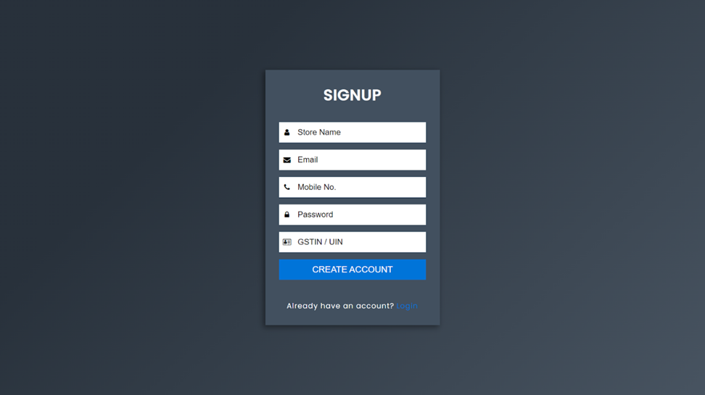

**LOGIN PAGE**

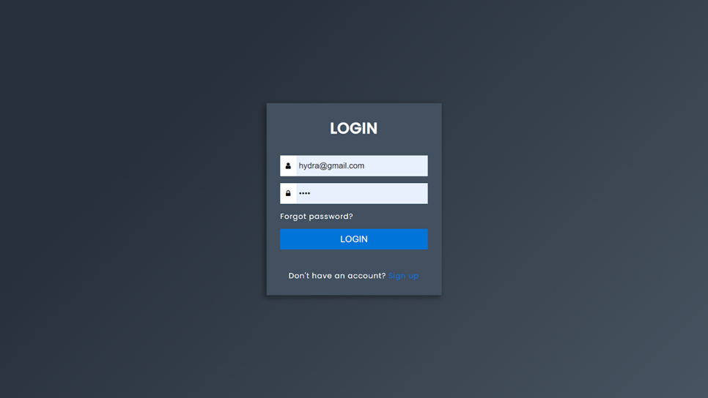

**HOME PAGE**

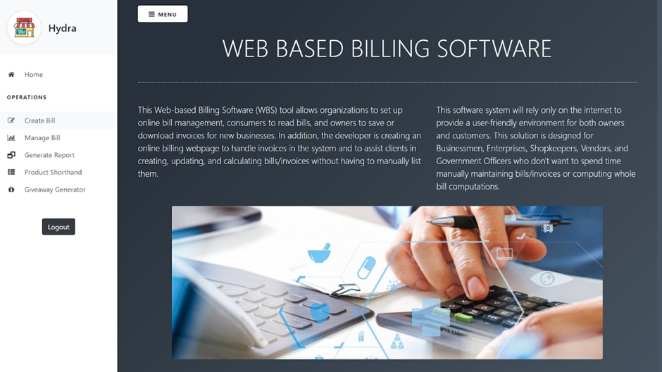

**BILL GENERATION**

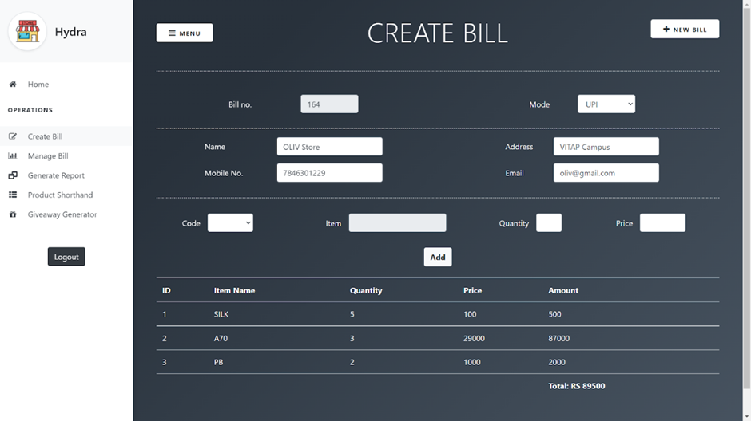

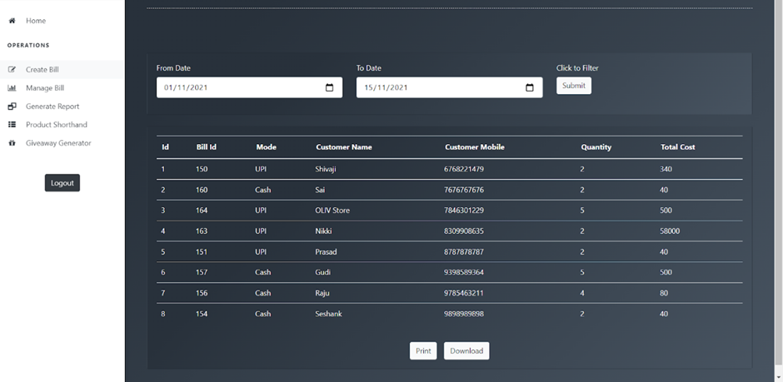

**BILL REPORT**

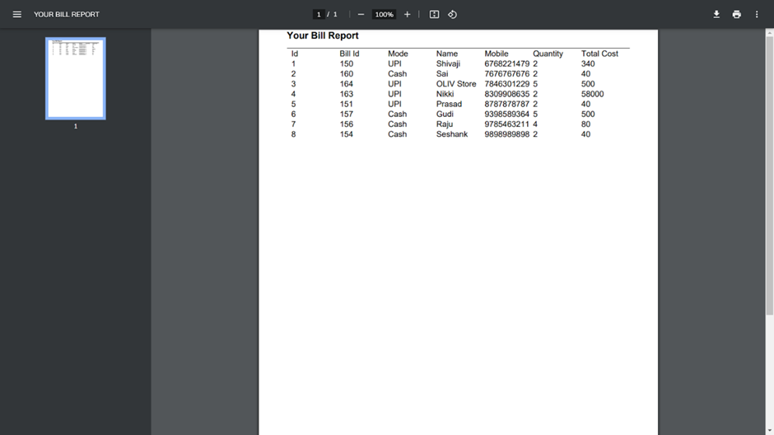

**PRODUCT SHORTHAND**

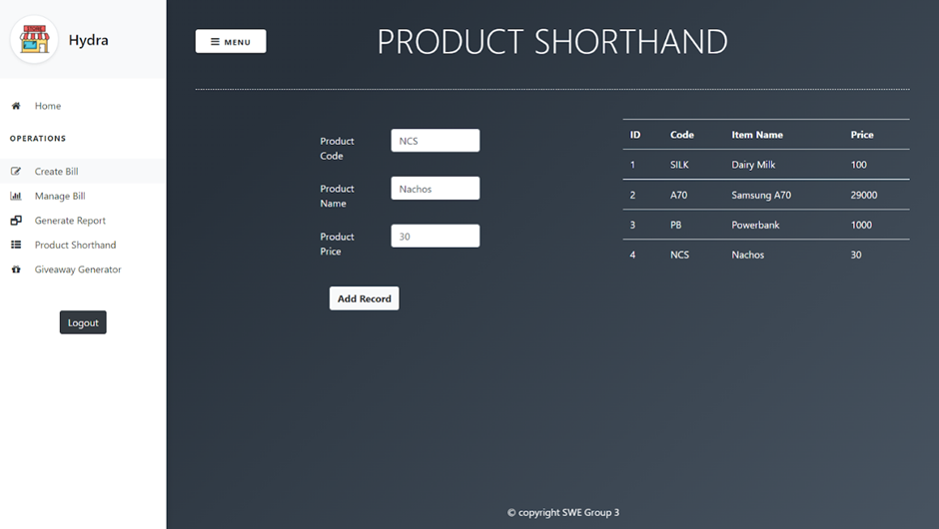

**GIVEWAY GENERATOR**

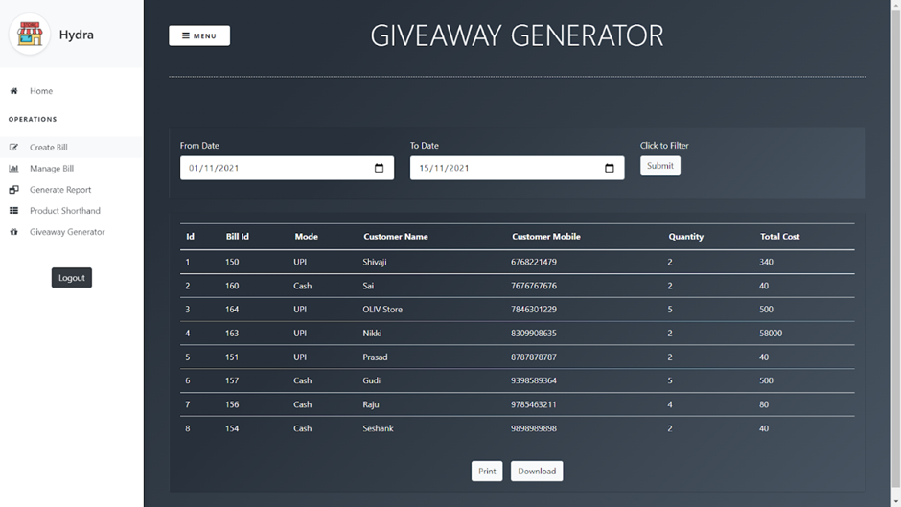

**ADMIN LOGIN**

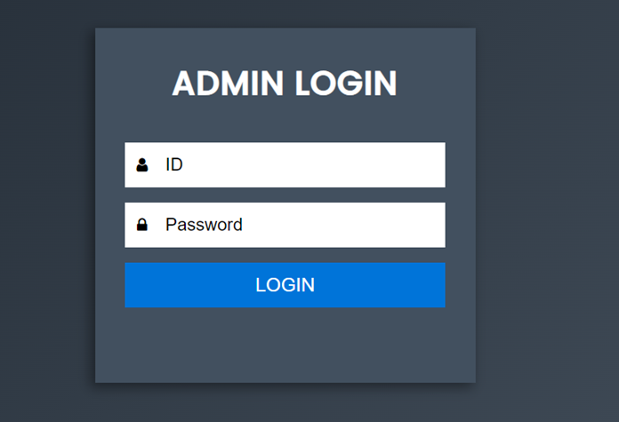

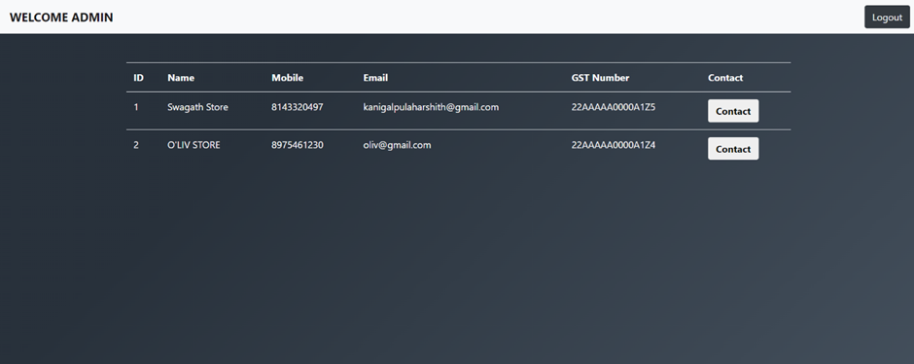

**TESTING:**

1. Testing Login Page, the user credentials are properly validated. Expected output is matched with actual output.

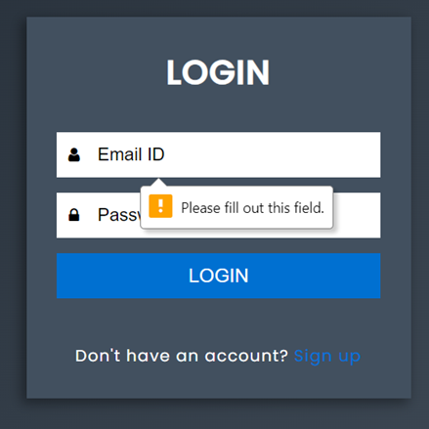 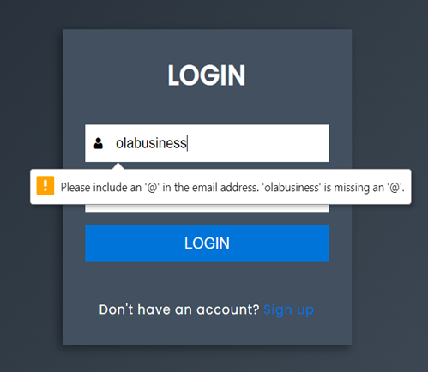

2. When a user credentials and actual credentials don't match, handling the error and displaying with proper error message.



3. When empty product details are added to the product list, It is not being handled properly. Expected output is not matching with actual output.

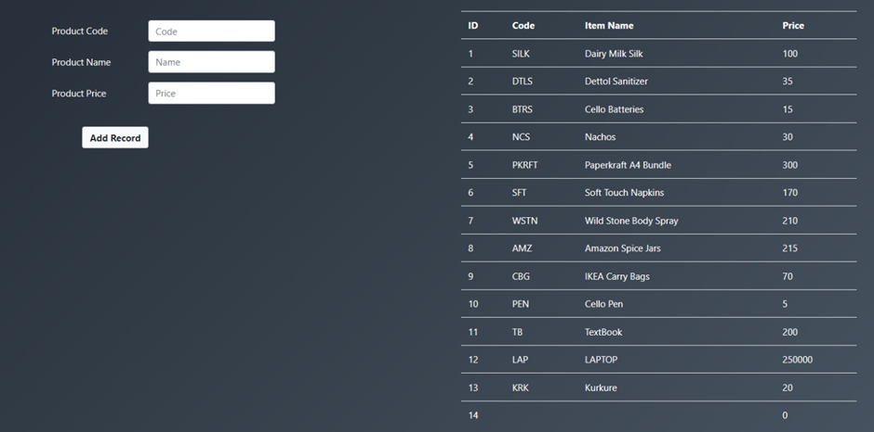

4. Billing for an empty product detail. It is not being handled properly. Expected output is not matching with actual output.

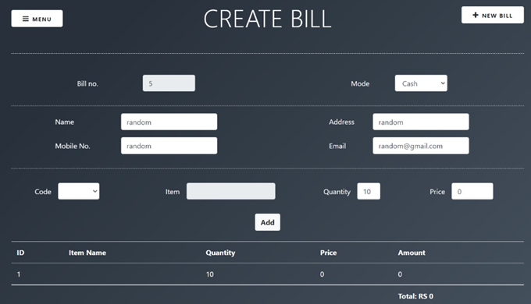

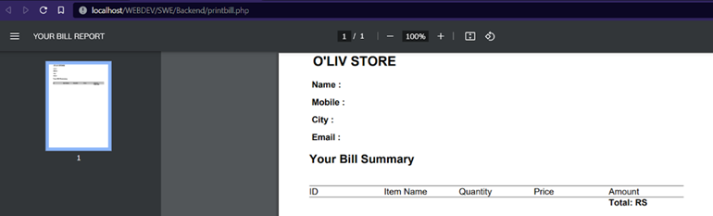

5. The list of random user records that is generated for no. of records is accurate. Expected output matches with actual output.

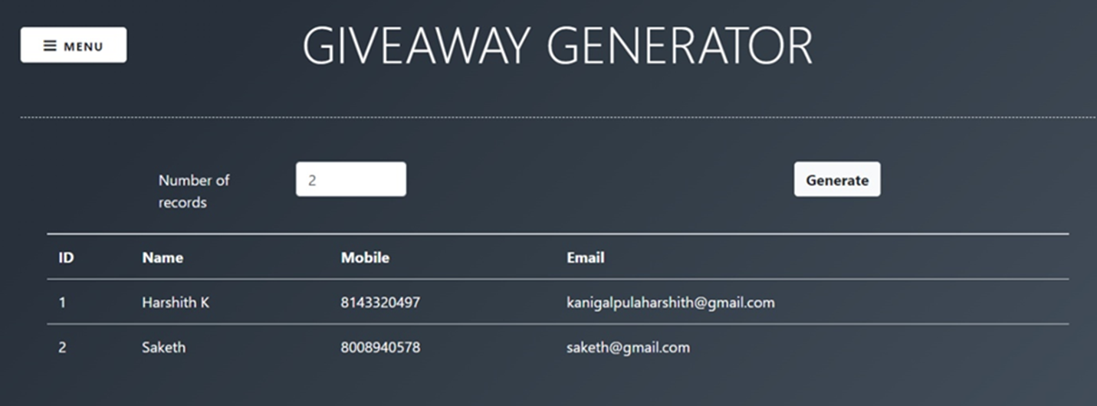

6.The list of random user records that is generated for no. of records entered is not validated. Expected output is not matching with actual output.

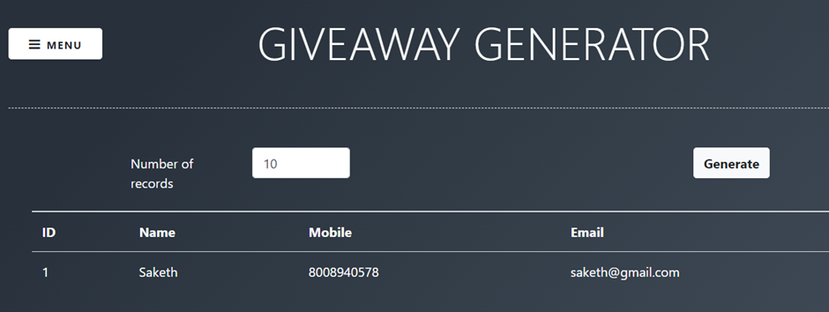

7. A working modal (popup) for Manage bills - Edit button. Expected Output matches with actual output.

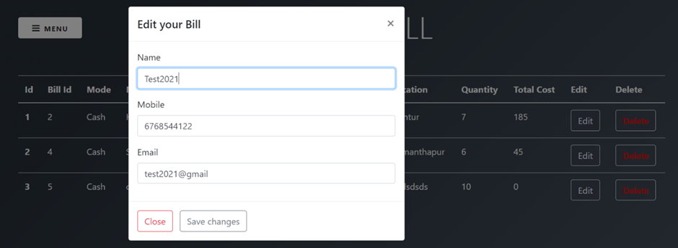

**REQUIREMENTS SPECIFICATION**

**2.1 Hardware requirements**

Intel Core i5 3rd Gen processor (i5 3450 3.1 GHz) or above (Depends on the number of clients)  
**RAM:** 2GB or above  
**OS:** Windows 7 (all editions) or Windows 8 or Windows 10

**2.2Software requirements**

HTML5, CSS3, JavaScript, Bootstrap, PHP, MySQL ,phpMyAdmin ,Lucid chart ,Heroku or Infintityfree, Visual Studio, Code, Chrome.

**ANALYSIS**

**3.1 Existing System**

a. Difficult to maintain bills and manage huge data manually.

b. Reports are difficult to generate from existing data.

c. Full or a lot of paperwork and Time consuming.

d. Inability of modification of data.

**3.2 Proposed System**

a. Easiness in maintaining and modification of sold products.  
b. Reports are simple to implement, create, generate within no time.  
c. No or very few paperwork.

**3.3 Feasibility study**

**a. Technical Feasibility:**

|  |  |  |  |
| --- | --- | --- | --- |
| **S. No** | **Tools /Technology needed** | **Description and uses** | **Type** |
| 1. | HTML5 | Appearance of website | Front-end Software |
| 2. | CSS3 | Adding style and presentation to the webpages | Front-end Software |
| 3. | JavaScript | Adding interactive user behavior to web pages | Front-end Software |
| 4. | Bootstrap | front-end framework used for UI | Front-endSoftware |
| 5. | PHP | Server-side programming andinteractive with phpMyAdmin | Back-endSoftware |
| 6. | MySQL | For the purpose of a web databaseand logging application | DatabaseSoftware |
| 7. | phpMyAdmin | Management of databases, tables,indexes, permissions | DatabaseSoftware |
| 8. | Lucid chart | a web-based proprietary platform tocollaborate on drawing charts anddiagrams | Design ToolSoftware |
| 9. | Heroku or Infintityfree | a container-based cloud Platform as aService to deploy, manage, scale apps | Cloud PlatformSoftware |
| 10. | Visual StudioCode | a code editor redefined, optimized forbuilding, debugging web apps | DesktopSoftware |
| 11. | Chrome | a cross-platform web browser | Software |
| 12. | Windows 10 | an operating system for building apps | OS |
| 13. | PC / Laptop | Intel based processor-run computer system, which have keyboard and mouse as input devices. | Hardware |

**b. Behavioural Feasibility:**An assessment of end-user behavior that may have an impact on the system's Encirclement. People are naturally reluctant to change, and computers must be cognizant of this in order to support changes. Since the proposed system's sole purpose is to meet information demands,  
no employees would lose their jobs as a result of it. Because it supports the organization and its strategic objective, this software solution is also possible for enterprises.

**c. Economic Feasibility:**

|  |  |  |
| --- | --- | --- |
| Type | Quantity | Figures |
| Human Power | 5 to 6 members | $25 - $30 per day per head |
| Software | - | $40 - $50 approx. |
| Hardware | 3 or 4 sets | $80 - $100 approx. |

**Total estimated budget - $4000 - $4500**

**DESIGN**

**4.1 Software architecture diagram**

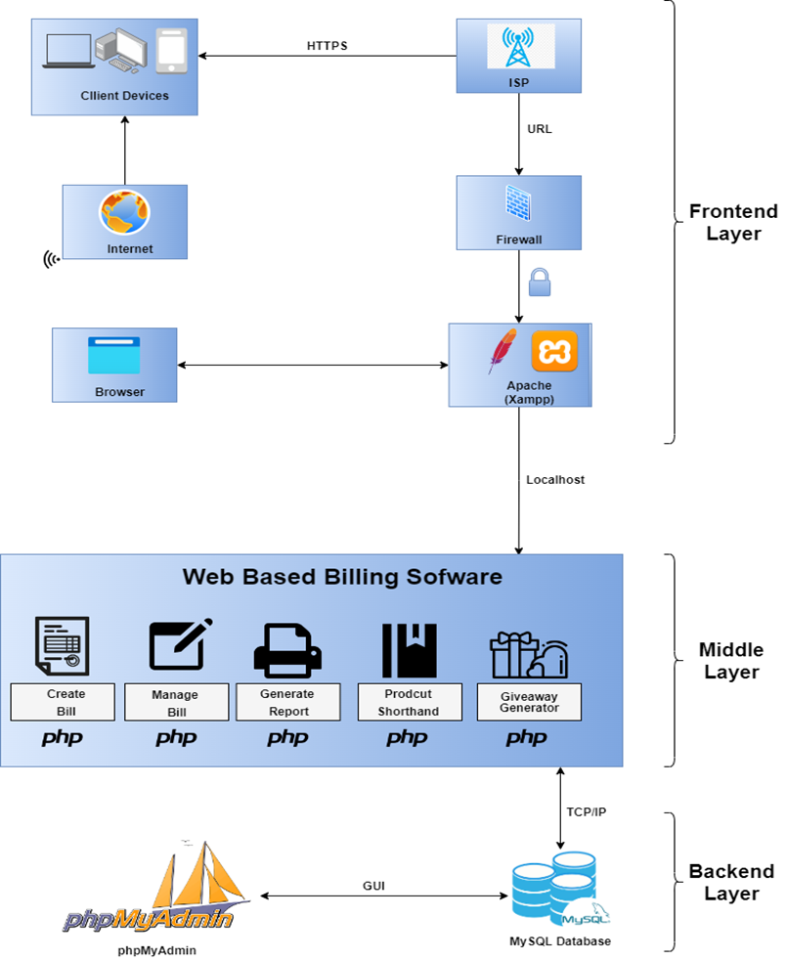

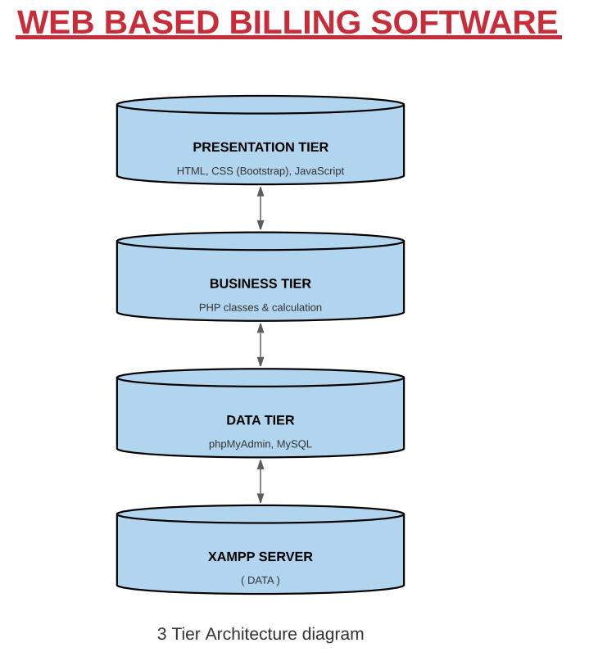

4.1.1 UML Diagrams

**USE-CASE DIAGRAM**

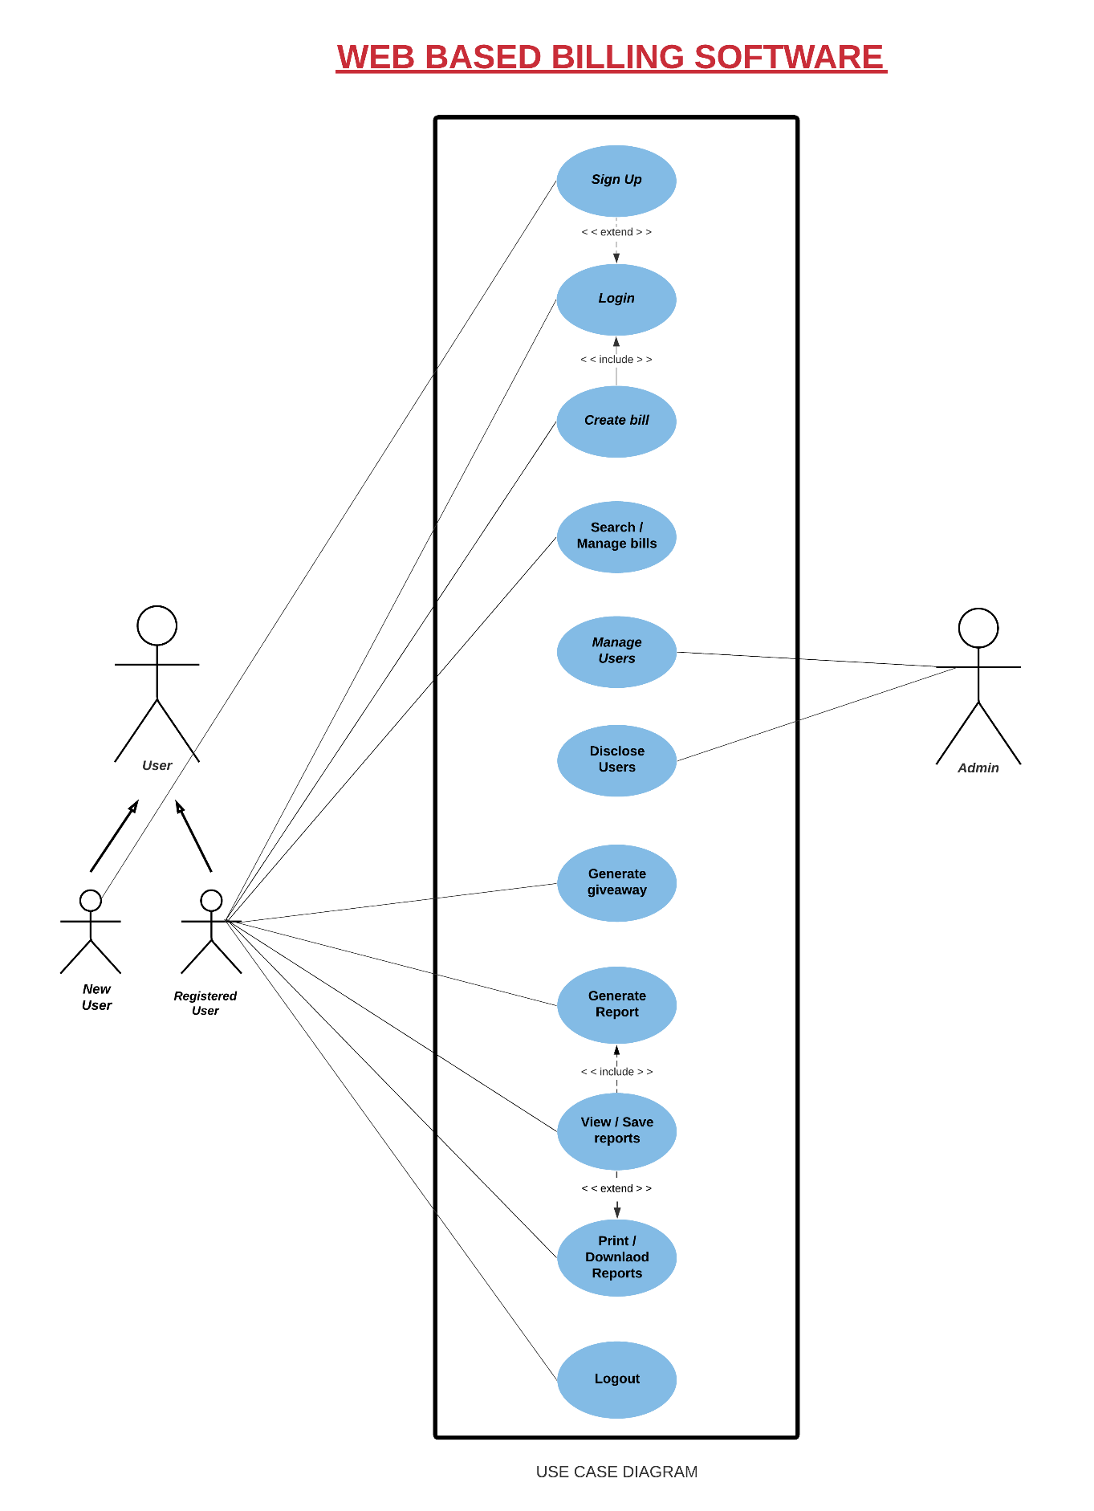

**ACTIVITY DIAGRAM**

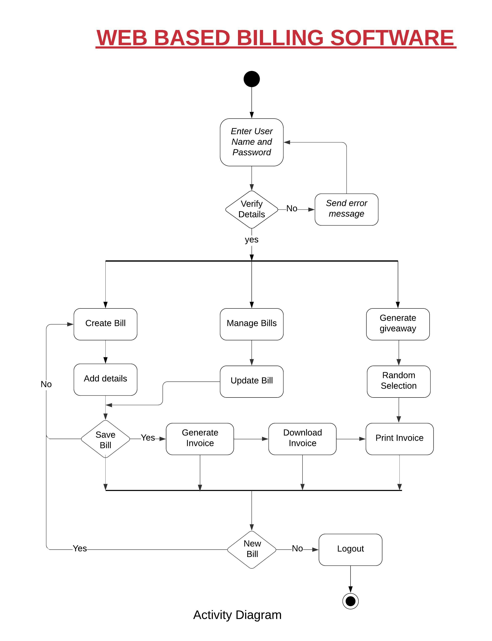

**CLASS DIAGRAM**

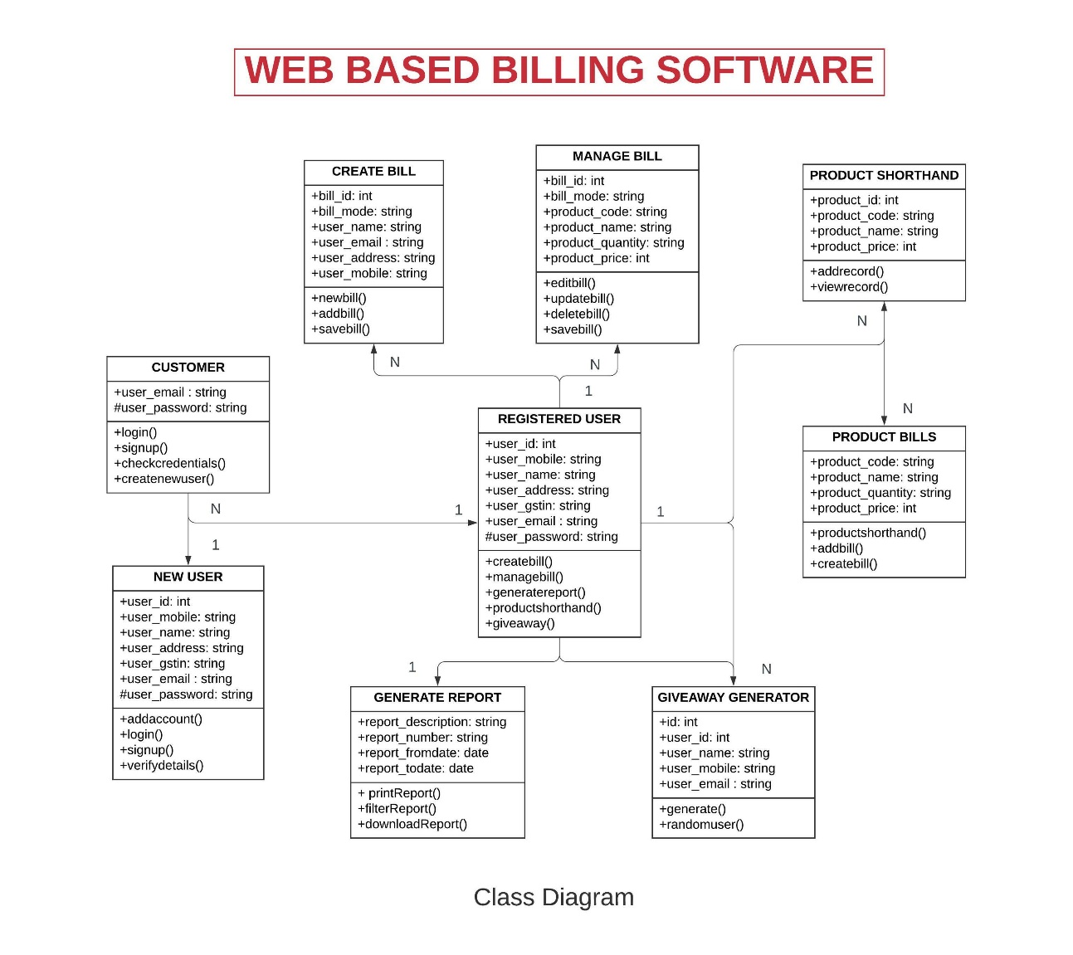

**COLLABORATION DIAGRAM**

**SEQUENCE DIAGRAM**

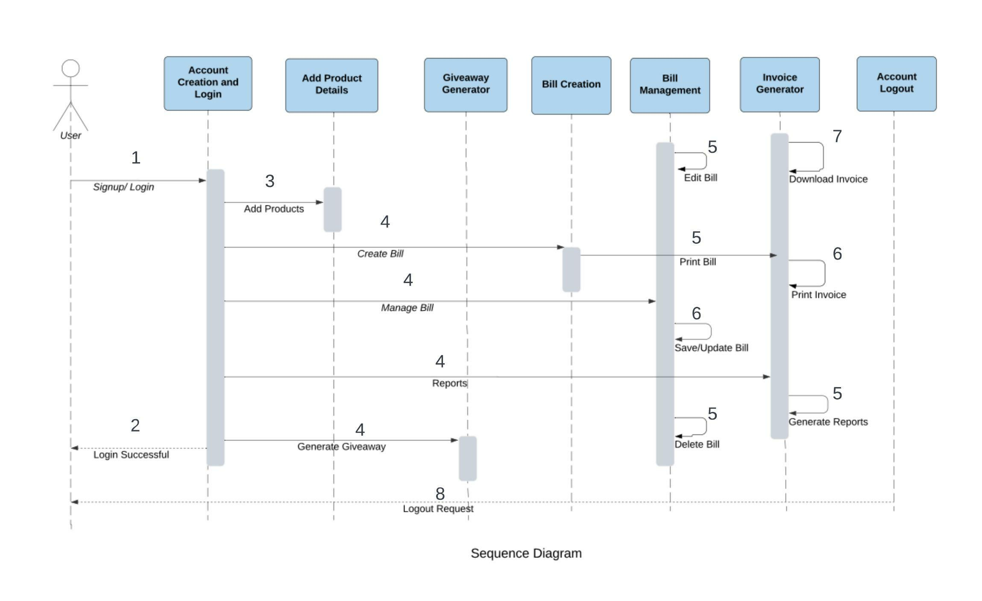

**DEPLOYMENT DIAGRAM**

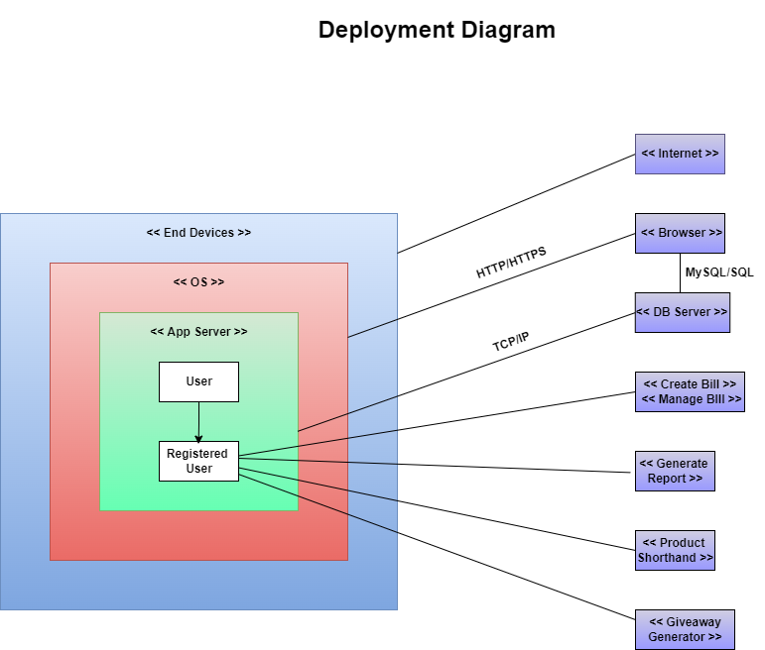

**CONCLUSION**

Since the prior method was manual, it necessitated a lot of paperwork and made it impossible to keep track of all previous sales, products, and stock. The system will provide the benefit of keeping track of all sales and stock at any given moment, reducing paperwork and, as a result, errors. Here's where our app comes in, since it will make the process of keeping track of purchases a lot easier. Currently, it involves a lot of paperwork, which takes time and is prone to error. With a new system, work could be done much faster and more accurately.

**THANK YOU**